Using Teams to Run Microsoft 365 Live Events

Posted on [**April 8, 2020**](https://office365itpros.com/2020/04/08/teams-live-events/) by [**Tony Redmond**](https://office365itpros.com/author/thoughtsofanidlemind/)

Multiple Forms of Teams Meetings

Recently I discussed the [**difference between personal Teams meetings and channel meetings**](https://office365itpros.com/2020/03/31/invitations-teams-meetings/). Let’s throw Teams Live Events into the mix and give some guidance about when you might want to run a live event instead of a regular Teams meetings.

Live and Structured Events

A Microsoft 365 live event is a structured form of meeting intended to be used for large-scale information dissemination such as company announcements, product launches, town halls, training, and so on. A live event can last up to four hours and can be created using Teams, [**Stream**](https://docs.microsoft.com/en-us/stream/live-event-overview), or [**Yammer**](https://support.office.com/en-ie/article/organize-a-live-event-in-yammer-105dd7af-9caf-4a5e-8a44-56d203e96551). The advantage of using Teams is that the integration of Live events into Teams makes setup and production of events very easy. Behind the scenes, Stream takes care of all the video processing, creation of captions and transcripts, analytics, and transcoding of the content for adaptive delivery to viewers. In other words, making sure that different forms of devices (workstations, browsers, and mobile) receive content in an appropriate form for them to consume.

Teams live events are available in the commercial version of Teams, including the government cloud.

Teams live events are created in the Teams calendar app in much the same way as a personal or channel meeting by selecting Live event from the *New meeting* drop-down menu. Figure 1 shows the screen used to father event information, including some of the roles played by different people in the event.

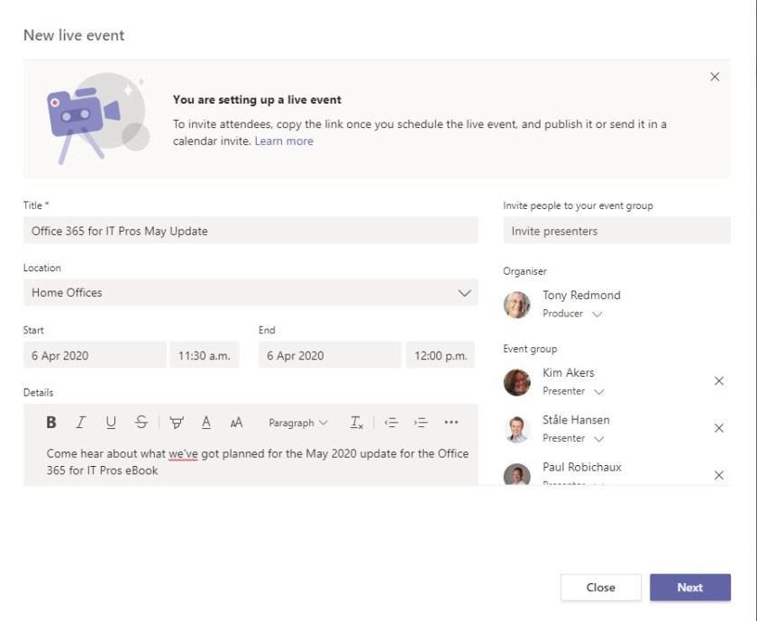Figure 1: Creating a Teams Live Event

The person who creates the live event is its organizer and its producer. Although other roles are available, like presenter (people entitled to speak and share content), a single person can do everything needed to run a live event. The event organizer must have an Exchange Online mailbox together with licenses for Teams and Stream. They must also have an Office 365 enterprise license (E3 or E5 or academic/government equivalents). Anonymous access is fully supported for attending live events.

It’s important to realize that Teams creates different joining links for presenters and attendees. The link used by presenters gives them the ability to speak and present material; the one used by participants allows them to listen. Don’t mix up the links you send to people! The event invitation for presenters contains a warning that you shouldn’t forward the invitation and instead should add extra presenters to Teams. This is to make sure that presenter links only go to people who need that level of access.

Live Event Permissions

The next step is to select the audience for the event. Three options exist (Figure 2):

* Limit the event to specific people and groups.
* Limit the event to anyone in the organization.
* Open the event to the world (including anonymous access).

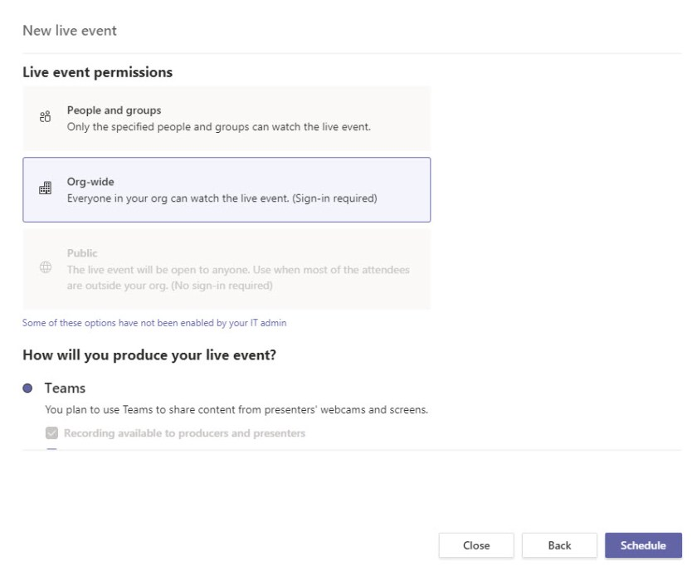Figure 2: Assigning permissions for a Teams Live Event

Organizers can choose anonymous access for an event if permitted by the live events policy assigned to their account. Live events policies are managed in the Teams Admin Center (Figure 3). Another important setting in this policy is “Allow scheduling.” If this is off, users assigned the policy won’t be able to schedule live events. Guests can’t organize or produce live events, but they can be a presenter at an event (a feature added in January 2020).

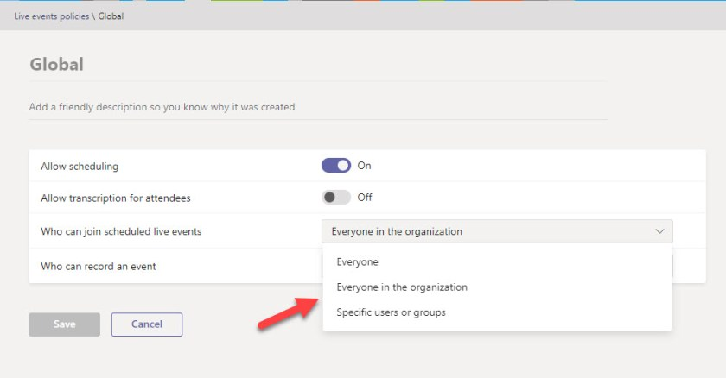Figure 3: Editing a Teams Live Events policy

Inviting Your Audience

After setting permissions for a live event, the next screen (Figure 4) summarizes the event settings. Make sure that the settings are right because you won’t be able to change them once the event starts.

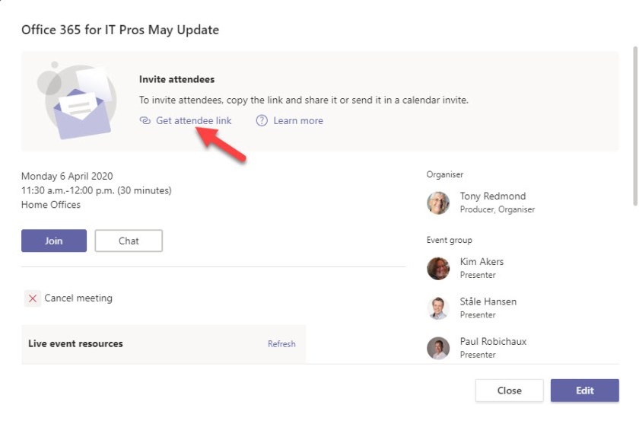Figure 4: Settings for a Teams Live Event

The important thing to note here is that you must take an extra step to distribute an invitation to attract an audience. This applies even if you explicitly limit permissions to attend the event to a selected set of people.

The right way to invite your audience is to click *Get attendee link* to copy the event link to the clipboard. Then paste the link into a regular calendar invitation sent to your intended audience. Don’t use a calendar invitation to a Teams meeting. The reason is simple: sending the link in a regular meeting avoids any clash with the meeting information inserted in an invitation created for a Teams meeting. Presenters receive a calendar invitation automatically which contains the special presenter link to allow them to present.

In a Live Event

Unlike regular meetings, where everyone can speak, share their video feed, and chat, only people assigned the producer, organizer, and presenter roles can speak, present information, and be seen during live events. Attendees can ask questions, but only through a moderated Q&A facility, and they can watch the recording of the live event later.

Figure 5 shows what a producer sees during a live event run from a PC’s webcam. A PowerPoint presentation is being lined up to be broadcast while the current feed is from the webcam. It’s very simple to switch from the webcam to the presentation using the **Send live** button.

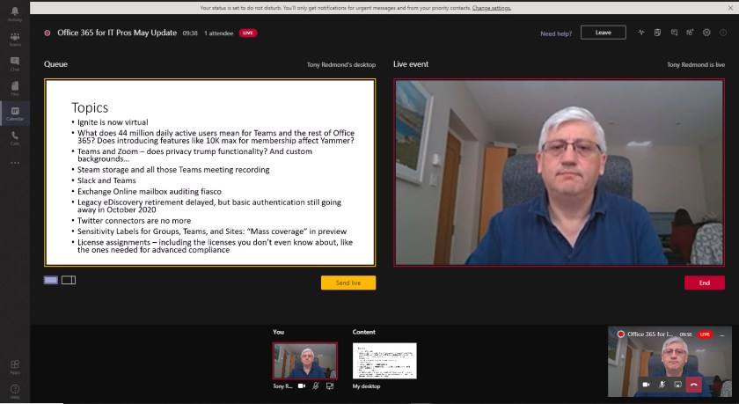Figure 5: Broadcasting in a Teams Live Event using a PC webcam

Producers and presenters must use the Teams desktop client and must switch into the tenant hosting the event. This seems obvious, but guests you invite to present might have to be warned to switch beforehand (a 15-minute reminder email normally does the trick). If guests don’t switch into the hosting tenant, they will join as an attendee and won’t be able to present. Attendees can join using any Teams client.

Running Smooth Events

Before an event, it’s wise to do a run-through with all presenters to review the material to be used to ensure that everyone knows what will happen, the running order, and their part. A dress rehearsal makes it less likely that awkward transitions will happen and improves the quality of delivery. It will also accustom presenters to the delay between them speaking and attendees hearing.

Just before the event starts, put up a holding screen and some music to inform attendees that the event will start soon. The music allows people to test their speakers and make sure that everything’s working properly before the presentation starts. Meanwhile, the event organizer can check that all presenters have joined and are ready to go. It’s better to pause until everyone is ready to run a professional event than create the impression of amateur night at the theater.

During the event, have someone assigned to monitor attendee questions and comments to make sure that important issues are addressed by presenters either during the main presentation or in a Q&A session at the end. The monitor can also have a screen open as an attendee to keep an eye on what attendees see and hear.

After the event is over, organizers can download information about who attended the meeting and how long their participation lasted.

Live Events Have Higher Limits

Because attendees have limited functionality in live events, the number of participants is much higher (10,000) than for normal Teams meetings (250). Live events are recorded and can be accessed by the audience for up to 180 days after the event using DVR-type controls, which makes it convenient for people to replay an event later and listen to specific parts.

Event organizers can download the recording and upload it to Stream if they want the recording to be available for longer than 180 days.

***Note****: To help organizations run events during the Covid-19 pandemic, Microsoft has*[***temporarily increased the limits***](https://docs.microsoft.com/en-us/microsoftteams/teams-live-events/plan-for-teams-live-events)*for Live Events as follows:*

* *Maximum attendees: 20,000 (from 10,000)*
* *Maximum length of event: 16 hours (from 4 hours)*
* *Maximum number concurrent of events per tenant: 50 (from 15).*

[***The temporary limits apply until October 1, 2020.***](https://techcommunity.microsoft.com/t5/yammer-blog/temporary-increase-to-20k-attendees-for-live-events-in-yammer/ba-p/1481839)

Largescale Live Events

Largescale live events which need output of the highest quality are often carefully-planned productions created with studio-quality recording, camera, and broadcast facilities. These events often involve external encoder software to connect to production equipment. Chapter 16 explains how to produce events of this nature.

You don’t need studio conditions to run a live event. Anyone equipped with a PC and webcam can create and run a live event. These events, called “produced with Teams,” are limited in terms of the video quality and perhaps the kind of information (like multiple video feeds) presented during the broadcast, but the output is more than good enough for many topics.

Using Live Events

Live events aren’t suitable for most Teams meetings. They’re designed for a specific scenario when there will be a limited number of presenters who share well-structured information that’s prepared in advance. You can certainly use a regular Teams meeting to address the same audience, but the extra control (and lack of distraction) available in Live Events make them a good choice when you need to broadcast information to non-participatory audiences.